Project Title: Contributing Factors to Texas Car Accidents

Team Members: Agust Erlingsson, Brittany Johnson, Carlos Villanueva Jr, Jared Sanderson, and Matt Terhune, Anthony Jones

Project description:

The purpose of this project is to identify whether three factors have a correlation to the severity of a car accident in the state of Texas. The three variables we will be looking at are the weather conditions, the time of the day, and the visibility. Our primary objective is to utilize our dataset to confirm or deny our assumption with the selected model implemented for the analysis and present our results to the rest of the class.

Dataset used: US Accidents (4.2 million records) A Countrywide Traffic Accident Dataset (2016 - 2020) *Sourced from Kaggle.com*

Research Question to Answer: Are the weather conditions surrounding a car accident, the time of day a car accident occurs and the visibility surrounding a car accident the three most important factors that determine the severity of car accident in the state of Texas?

*Does the weather conditions surrounding a car accident contribute to the severity of an accident in the state of Texas?*

There is a weak correlation between precipitation and severity of accidents. Overall, accidents of all types happen at all rainfall numbers.

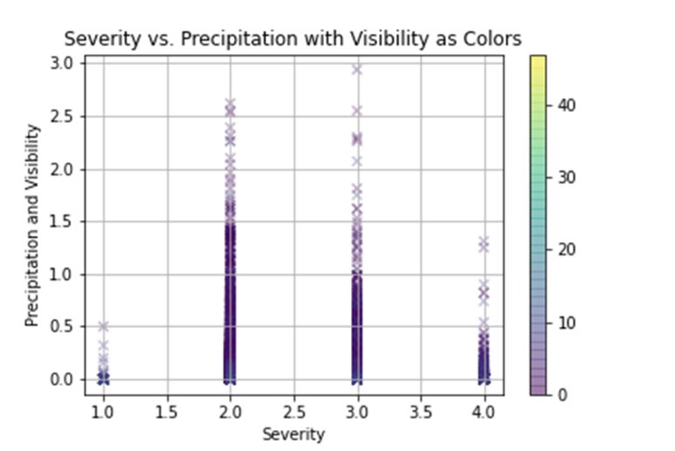

*Does the time of day a car accident occurs contribute to the severity of an accident in the state of Texas?*

Most of the car accidents in Texas happen in the morning to midday. The time of day an accident occurs does not have an effect on the severity of a car accident in Texas.

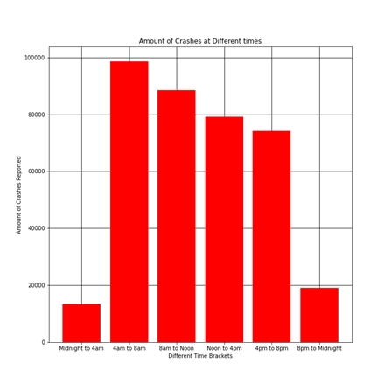

*Does the visibility surrounding a car accident contribute to the severity of a car accident in the state of Texas?*

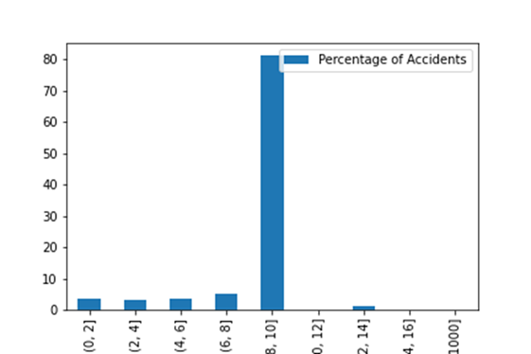Overall, we concluded that the visibility does not affect the severity of a car accident in the state of Texas.

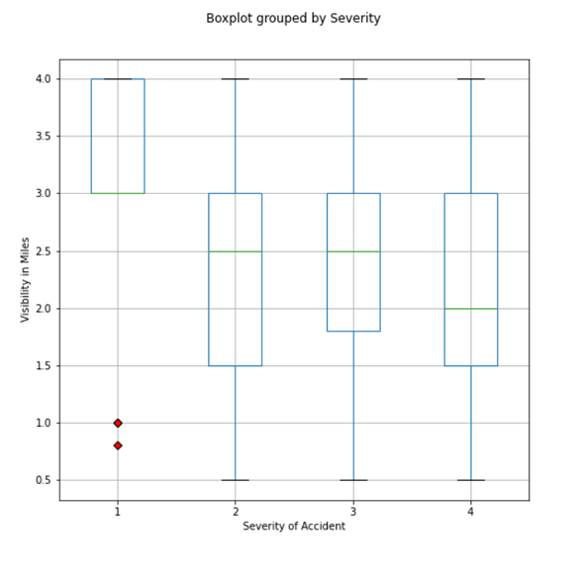

*How do other factors contribute to the severity of car accidents in the state of Texas?*

Texas urban centers represent the majority of accidents specifically along I-20, I-30 and I-45. With such a large portion of accidents in the urban areas, population is a leading factor as chance of having an accident is increase simply because of the amount of individuals on the road. There is a strong correlation between population size and accident occurrence. The more open the space is between vehicles, and the less there is traffic, the lower the severity is. The bigger traffic becomes when an accident occurs, the more severity it will have. The overwhelming majority of accidents are non-incapacitating, and less than 2% are fatal in Texas. The population heat map is a representation of the congested area and the markers show the zipcodes with the highest accident rates. We can come to the conclusion that the most populated areas have the most accidents. The data showed that 80% of the accidents that are reported are of severity 2. The rest of the accidents are majorly severity 3, and we come to learn that the more dense and busy traffic is, the more this severity level will increase at the time of a car accident. The final takeaway is that in all types of traffic, fatal accidents only constitute 1% of the accidents reported.

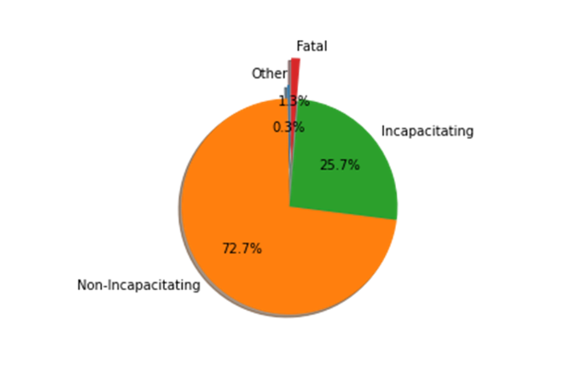

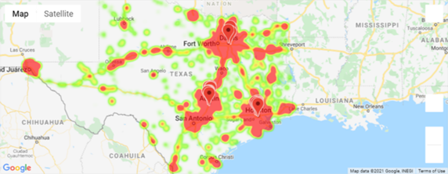

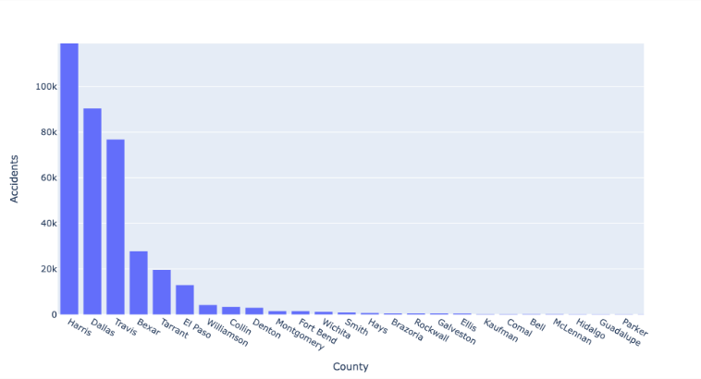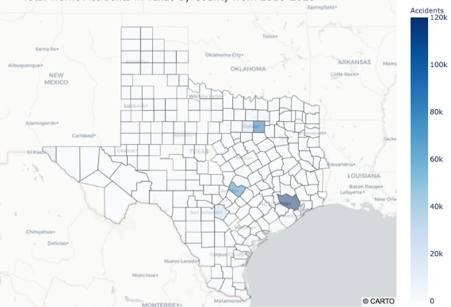

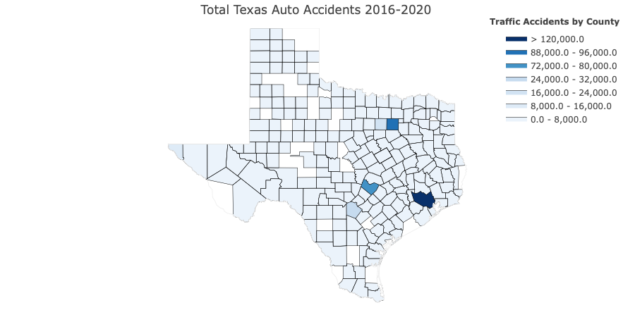

Overall Conclusion:

The main factor that contributes to the severity of car accidents in the state of Texas is population density.